May 26th, 2025
Muinat Bello
No18b Sango Oke Andi Primary School,
Ilorin, Kwara State.
09122755097

Dear Muinat,
OFFER OF EMPLOYMENT

We are pleased to offer you the position of Front Desk Support at Ilorin Innovation Hub. We are confident that your skills and experience will be a valuable addition to our team. Your employment is provisional for the probationary period of 3 months. Upon successful completion, your employment will be confirmed in writing.

Position Details
- Position Title: Front Desk Support
- Department: Admin & HR
- Reporting Line: Admin & Front Desk Associate
- Employment Type: Full-time
- Start Date: June 2, 2025
- Work Location: Ilorin Innovation Hub, Ahmadu Bello Way, Ilorin, Kwara State

Compensation & Benefits
- Monthly Salary: NGN 124,694.93 (net)
- Allowances: Transport, housing, meals, utility, entertainment
- Other Benefits: Health insurance, life insurance, pension, 13th month salary, cafeteria subsidy, mobile device, airtime & mobile

Work Schedule
Your official working hours will be 8 AM – 5 PM, Monday to Friday, in accordance with company policy. Further details regarding leave, probation, and other terms will be provided in your employment contract and employee handbook.

Acceptance Instructions
To accept this offer, please sign and return a copy of this letter by May 30th, 2025. If you have any questions, feel free to reach out. We look forward to welcoming you to the Ilorin Innovation Hub.

For Ilorin Innovation Hub
Temi Kolawole
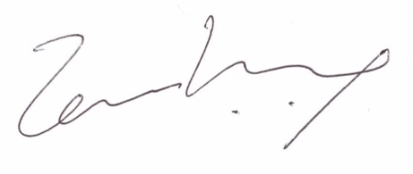
Managing Director
For Employee
Muinat Bello
Signature: ________________
Date: ________________

